Teaching Handbook
Promoting a Positive Learning Environment
Jacinta Kyratzoulis-Foulds

Contents

Introduction 1
Preventative Actions 4
Supportive Actions 8
Corrective Actions 11
Conclusion 14
Reference List 15

Introduction

This handbook has been created to promote a positive learning environment. In order for students to achieve their best the classroom needs to be a supportive, fun, safe, encouraging and interesting place. The outcome of this handbook is to provide a set of strategies that teachers can implement to create and achieve a positive learning environment for all students. This handbook focuses on positive interactions with students. It is encouraged for teachers to establish strong preventative measures in the classroom and curriculum. This creates an environment where misbehaviour is kept to a minimum. Handbook sections are placed into subcategories. The subcategories range from preventative (no confrontation), to supportive (little confrontation), to corrective (high confrontation levels). Charles states that the most effective techniques are consistent with teacher’s values (2002). The strategies included in this handbook reflect the following values of compassion, responsibility, respect, integrity and harmony. The strategies used in this handbook allow students to be responsible for their own behaviour. These strategies also foster respect between teacher, student and classmates. The classroom needs to be happy and supportive environment for students to achieve their best.
Preventative Actions

A classroom needs to be a supportive, engaging and effective learning environment. Teachers use preventative actions to support the engaging learning environment. Charles encourages teachers to use preventative actions to prevent student misbehaviour (2002). Jacob Kounin developed a management strategy that uses preventative measures which allows the teacher to maintain control over the classroom. Kounin approach uses 5 preventative methods:
- "With-it-ness"
Teacher is consciously monitoring the classroom at all times and aware of students actions and behaviour (McInerney et. Al. 2002).
- Overlapping
Teacher responds to more than one behaviour at once (McInerney et. Al. 2002).
- Momentum
Momentum happens when a teacher is, ‘starting activities promptly, keeping their pace energetic and closing them decisively,’ (McInerney et. Al. 2002).
- Smoothness
Teacher moves from one activity to the next smoothly, and therefore resulting in student attention (McInerney et. Al. 2002).
- Group focus
The teacher will keep students actively engaged and on task (McInerney et. Al. 2002).

When using Kounin’s approach to behaviour management it is recommended that teachers use all five steps together to create a whole. Using all steps together creates a fluid, logical and whole approach to classroom management.

One preventative action Charles promotes is creating an enjoyable and valuable curriculum (Charles 2002). To accomplish this, teachers can use Gardner’s theory of Multiple Intelligences to create and adapt the curriculum to different learner’s needs. Gardner’s Multiple Intelligences comprise of eight different learning styles. Gardner argues that there is not just one type of human intelligence but eight different types of intelligences (Phillips 2010). Therefore, different people might have a stronger learning preference than others. Using Gardener’s Multiple Intelligence in curriculum writing and lesson planning allows teachers to create varied lessons that students will be able to succeed in,
More students can be reached by teaching concepts in a variety of ways. Finally, frame assessment so that students can demonstrate their knowledge using their stronger intelligences (Phillips 2010)
Tailoring curriculum is a strong strategy to use to gain student attention and interest. If the curriculum is tailored to student’s needs; students will feel like they can achieve and succeed in class. This strategy can be seen in Phil Beadle’s teaching in Argument Tennis (Schools World TV). In this episode, Beadle tailors the curriculum to his student’s needs. Beadle has a class of highly kinesthetic boys so he makes English interactive and fun to suit their learning styles. This has been a success for Beadle and his students.

Preventative Strategies:

Curriculum strategies:
- Creating lessons that students can succeed in
In the clip, Too Much Talk, the teacher created successful lessons so students could succeed and achieve. This is linked to Kounin’s ‘with-it-ness’ theory.
- Negotiate curriculum with students
Allowing students to make choices and decisions with their curriculum allows them to feel important and part of the decision making process. It also fosters responsibility and accountability within the class (Teaching with Bayley, The Need for Structure). This strategy is linked to Glasser’s theory.

Classroom strategies:
- Positive feedback
Giving genuine and regular positive feedback to students to encourage on task behaviour. This strategy was significantly used successfully in the following clips; Too Much Talk, Phil Beadle and Praise and Preparation with Amy.
- Positive reinforcement
Starting questions with a positive outlook, ‘Who can impress me’ fosters positive competition and on task behaviour (Manage That Class).
- Positive reinforcement on whiteboard/smart board
In Praise and Preparation teacher, Amy, writes students names on the board who are on task and achieving. This small and silent gesture gives attention to on task behaviour and gives off task behaviour students a silent positive signal to get back on task.
- Knowing student names to foster positive student/teacher relationship
A key to building positive relationships with students is to know each student’s name. Michelle used this successfully in, The Need for Structure. This strategy is linked to Kounin’s ‘with-it-ness’.
- Providing students with clear aims and goals at the beginning of the class
Stating the goals and aims of the lesson at the beginning of each class allows students to know what they need to be doing. It also allows them to understand what knowledge they will leave the class with (Manage That Class).
- Strict routine
In Praise and Preparation teacher, Amy, creates a strict routine with her class. Students therefore know what to expect upon entering the classroom.
- Sound and Visual
Phil Beadle uses an effective strategy of clicking and making a sound to gain a
- Student Movement
Phil Beadle encourages and forces student movement within his classroom activities. This ensures retained attention levels as well as building emotional connections to work. This is a perfect example that movement can happen in English classes.

Teacher behaviour strategies:
- Reflection
It is important for teachers to reflect to improve their own practice (Praise and Preparation).
- Careful and rigourous marking
Phil Beadle believes that by regularly marking student work and marking with rigour let’s students know that you care. It also sets a standard for students and gives them motivation to do the task well.

Supportive Actions
Preventative techniques help to focus student behaviour and are used to prevent misbehavior or off task behaviour. Supportive techniques are used to bring students back on task, when they may have deviated off task. Charles states that supportive actions, ‘are pleasant yet effective in keeping students engaged in their work’ (2002). These techniques are to alert students that they are off task and they need to come on task, the student has not reached the corrective stage yet.

Scaffolding can be used as a positive and supportive behavioural management technique. Scaffolding has been created from Lev Vygotsky’s Zone of Proximal Development theory (ZPD). ZPD is, ‘the distance between children’s current level of competence on a task and the level they can achieve with support or guidance,’ (Bochner Et. Al.) This theory can be put into practice by scaffolding a student’s work. Bochner Et. Al. suggest for teachers to break tasks up to manageable pieces (2003). To use scaffolding or ZPD as a supportive behavioural technique teachers can scaffold down or up according to the student’s needs. If a student is misbehaving because they are bored, the teacher could scaffold up or focus instruction on tasks that are in the Zone of Proximal Development, not on tasks that the student can already achieve independently (Bochner Et. Al. 2003).

Supportive strategies
Classroom strategies
- Tactical Ignoring
When a student interrupts classroom discussion, on task behaviour or teacher instruction with a noise, clap or short term interference the teacher can choose to tactically ignore the student (Levin and Nolan 2005). By not looking or responding to the interfering student the teacher is not supporting negative behaviour (Levin and Nolan 2005). This tactic was also used by Nicola in Girl Talk.
- Signal interference
Signal interference can divert student attention to on task behaviour. The teacher can signal to a student to sit down, be quiet, or even just make eye contact (Levin and Nolan 2005). The student should understand from this nonverbal command that the teacher is aware of their behaviour and the student needs to take responsibility for it (Levin and Nolan 2005).
- Proximity
A teacher can use their proximity to students to gain their attention and focus off task behaviour, such as talking when the teacher is speaking, to on task behaviour. Levin and Nolan suggest conducting the lesson close to the student’s desk to gain student focus (2005). Nicola Lamb uses this in in the clip Girl Talk.
- Open ended questioning
Open ended questioning can redirect off task behaviour with low confrontation. Simply asking the student how they are going with the task or a question about the task can refocus attention. This is evident in The Need for Structure and Too Much Talk.
- Questioning Awareness of Effect
Questioning awareness of effect differs to open ended questioning. This form of questioning relates directly to the behaviour of the student and draws the student’s attention to their behaviour. The aim of corrective questioning is for students to learn to regulate their own behaviour (Levin and Nolan 2005).
- Student lateness and positive reinforcement
When students come to class late, do not stop the class, keep going with the class and acknowledge the student by saying something positive. ‘Thanks for joining us today’ ‘Glad you’re here’. This is a supportive measure used in Love Them or Loathe Them.
- Ripple Effect
Kounin’s Ripple Effect is a positive strategy used by teachers to promote on task behaviour. The goal of the ripple effect is for the teacher to applaud and praise on task and positive behaviour. Students will then join in on the on task behaviour because they are seeking the positive reinforcement. This theory can be seen in a positive and negative way in Attention Seekers. In this clip Jane, the teacher, is able to successfully promote on task behaviour with her students.

Corrective Actions
Teachers need to use corrective techniques when student misbehaviour has reached a limit and the teacher needs to increase confrontation. Charles states, ‘If you approach misbehaving students in a sensitive manner, you can help them return to proper behaviour with no ill feelings’ (2002). It is important to remember to continue to approach confrontation in a positive manner to reinforce good behaviour this allows the student to be able to return to the class in a positive headspace.

Levin and Nolan have created a Hierarchy for Management Intervention (figure one). These interventions range from student centered, less confrontation and less disruption, to teacher centered, more confrontation and more disruption. Level one and some of level two have been included above in supportive actions. There are times when a higher level of confrontation is needed. The teacher can use the teacher centered corrective actions.

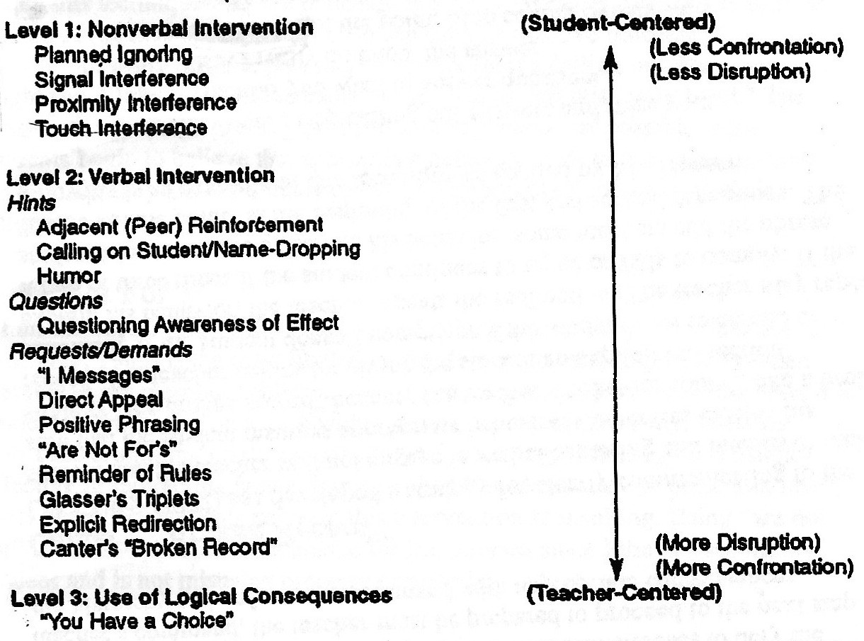
Figure One (Levin and Nolan 2005)

The corrective measures from Levin and Nolan’s Hierarchy to highlight:
- I Messages
Gordon’s I messages is a corrective measure for students to realise their undesirable behaviour has a negative effect on their teacher. The I message is a three part message which aims to get student’s to regulate and be responsible for their own behaviour. The three parts of the I message are:
- Description of negative behaviour
- Description of the effects of this behaviour on the teacher or other students
- Description of the teachers feelings about the effects of the misbehaviour (Matthews 2015)
Using I Messages creates an authentic relationship between student and teacher (Matthews 2015).
- Glasser’s Triplets
Glasser’s Triplets is a directive technique to move students towards appropriate behaviour by using three types of questions/statements (Levin and Nolan 2005). When using this strategy, the teacher needs to be direct and concise (Matthews 2015). The three questions or statements are:
- What are you doing?
- Is it against the rules?
- What should you be doing?

- Logical consequence
Logical consequence is situated in level three of the hierarchy. It is the most confrontational technique and is used when verbal and nonverbal techniques have not lead to appropriate behaviour (Levin and Nolan 2005). It allows the student to have a choice in their behaviour and gives the student a chance to enter into good behaviour. It is important that the teacher logically connects the consequence and the poor behaviour. Example; ‘If you keep throwing rubbish on the floor then you will need to pick up school yard rubbish at recess,’ (Matthews 2015).

Corrective strategies
Classroom strategies
- Separating behaviour from person
In Praise and Preparation teacher, Amy, uses this strategy to separate the behaviour from the person. An example, ‘I would like it for that behaviour to stop so you can continue your work,’ (Praise and Preparation). This allows the student to realise their behaviour and choose to behaviour correctly. This technique comes from Bill Roger’s theory of classroom management (Matthews 2015).

Conclusion

This handbook advocates for a holistic approach to behavioural management. Positive reinforcement and positive outlook are integral to running an effective and enjoyable classroom. Preventative measures can be implemented in the classroom but also in curriculum building and reflective practice. Incorporating preventative measures in each element of teaching provides the teacher with a strong and coherent behavioural structure within the classroom. Using Kounin’s 5 strategies with Vygotsky’s ZPD and Levin and Nolan’s Hierarchy for Management Intervention graph gives a wide range of curriculum and classroom based strategies. Positive reinforcement is the overarching technique of this handbook. Positive reinforcement is a strategy at every level, preventative, supportive and corrective. The way the reinforcement occurs is what changes between the levels. Positive reinforcement at preventative level is giving students genuine and regular feedback. It is used to build relationships. At a supportive level positive reinforcement is used to divert student’s attention from off task behaviour to on task behaviour. Finally, at the corrective level, positive reinforcement is used to separate behaviour from the student and allow the student to choose the correct behaviour. By implementing these strategies, teachers are able to foster effective and successful working relationships with their students.

Reference List:

Theorists:
Bochner, S, Duchesne, S & Krause, KL 2003, Educational Psychology for learning and teaching, Thomson.

Charles, C 2002, Building Classroom Discipline, Pearson.

Levin, J & Nolan, J 2005, What every teacher should know about classroom management, Pearson Education Inc.

Matthews, R 2015, ‘The Positive Classroom’, lecture notes in the topic Educ 4520 Student Teacher Interaction.

McInerney, D & McInerney, F 2002, Educational Psychology, Prentice Hall.

Phillips, H 2010, ‘Multiple Intelligences: Theory and Application’, Perspectives in Learning, vol. 11, no. 1, pp. 4-11.

Clips:
Schools World, Phil Beadle Argument Tennis, Schools World http://www.schoolsworld.tv/node/263

Teaching with Bayley, Girl Talk, Schools World
https://www.tes.co.uk/teaching-resource/teachers-tv-teaching-with-bayley--girl-talk-6081865

Teaching with Bayley, Love Them or Loathe Them, Schools World http://www.schoolsworld.tv/node/1265

Teaching with Bayley, Manage That Class, Schools World http://www.schoolsworld.tv/node/1752

Teaching with Bayley, Praise and Preparation, Schools World http://www.schoolsworld.tv/node/273

Teaching with Bayley, The Need for Structure, Schools World http://www.schoolsworld.tv/node/272

Teaching with Bayley, Too Much Talk, Schools World http://www.schoolsworld.tv/node/271

